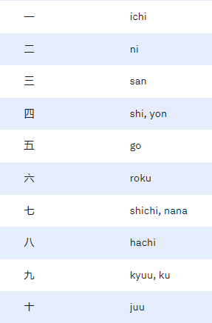Introduction  
Whenever we learn a new language, it is super important to learn how to count. Counting is very crucial for everyday life from counting coins to expressing our demands.  
  
Counting in Nihongo is pretty easy! It’s just like how you count with other languages, so don’t worry, you will get better.   
  
So, if you're ready? Let’s Start!  
  
  
Counting 1-10  
If you look at your hand, how many fingers do you see? Yes! Ten!. And Counting in Nihongo is also based 10 just like other languages so we will start right there.  
  
Lets start with One, One in Nihongo is ( 一 or ichi) so start with ichi then Two which is ( 二 or ni ) then Three which is ( 三 or san ) and so on..

Counting 11-100

However, we can’t stop at ten we must pursue further. To start counting from ten we must add juu to other number like:  
  
に (2, ni) + じゅう (10, juu) + いち (1, ichi)

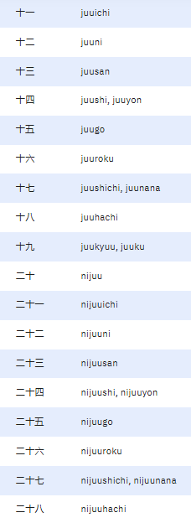And we got 21 ( two tens an a one)

Get the pattern?

To bigger numbers